WHAT’S NEW

Wasatch Front Travel Demand Model

Version 9.0.2

WFRC / MAG

July 8, 2024

Table of Contents

1 Overview 1

2 Changes To Input Files 2

2.1 Highway Network 2

2.1.1 Changes to Highway Network Due to Amendment #1 2

2.1.2 Changes to the Highway Network Rail Component 6

2.1.3 Added Network QA-QC Folder 10

2.2 Transit Networks 10

2.2.1 Changes to Transit Line Files Due to Amendment #1 10

3 Compare Model Results 11

3.1 Road Volume Comparisons 11

3.2 Transit Comparisons 14

List of Figures

Figure 2.1 Lanes and Functional Type Model Differences – 2019 3

Figure 2.2 Lanes and Functional Type Model Differences – 2032 4

Figure 2.3 Lanes and Functional Type Model Differences – 2042 5

Figure 2.4 Lanes and Functional Type Model Differences – 2050 6

Figure 3.1 Daily Volume Comparison – All Vehicles 12

Figure 3.2 Daily Volume Comparison – Medium+Heavy Truck 13

Figure 3.3 Daily Transit Trips - All Modes 14

Figure 3.4 Daily Transit Trips – Commuter Rail 15

Figure 3.5 Daily Transit Trips – Light Rail 15

Figure 3.6 Daily Transit Trips - Bus Rapid Transit 16

Figure 3.7 Daily Transit Trips - Express Bus 16

Figure 3.8 Daily Transit Trips - Core Bus 17

Figure 3.9 Daily Transit Trips - Local Bus 17

List of Tables

Table 2.1 Version 9.0.2 Transit Speed Field Correspondence to UTA FrontRunner Study Reference Fields 7

Table 2.2 FrontRunner Speed Differences – 2032 & 2042 8

Table 2.3 FrontRunner Speed Differences – 2050 8

Table 2.4 FrontRunner Travel Time Differences – 2032 & 2042 9

Table 2.5 FrontRunner Travel Time Differences – 2050 9

# Overview

Version 9.0.2 reflects the Amendment #1 changes to the WFRC & MAG Regional Transportation Plans (adopted May/June 2024).

The model processes and parameters in version 9.0.2 are the same as version 9.0.0 and version 9.0.1. Version 9.0.2 includes all the highway, transit, and segment maintenance and clean-up work completed up through version 9.0.1-patch2 (06-24-2024).

Changes to the model inputs in version 9.0.2 include updates to the highway and transit networks, as well as the creation of a few new folders and files that serve as resources.

Model comparisons between version 9.0.2 and version 9.0.1-patch2 were created to demonstrate the location and magnitude of roadway volume and transit ridership differences.

# Changes To Input Files

## Highway Network

### Changes to Highway Network Due to Amendment #1

The following edits were made to the highway network to account for Amendment #1:

* A HOT Lane on I-15 from Farmington to 2600 S was converted to a general-purpose lane (4 GP + 2 HOT 🡪 5 GP + 1 HOT) as a direct result of the EIS (section R-D-45)
* Highway network attributes were also updated in all phases of the plan to accommodate additional passing lanes for the operational project on I-15 in Box Elder from US-91 North to 3000 N
* Updated 12600 S from 6400 W to Bacchus Highway to 5 lanes
* Added Freedom Point Way from 100 W to Pony Express Rd (3 lanes)
* Removed lanes in 2023 and 2028 from Granville Ave from Old Bingham Highway to 10200 S
* Fixed **HOT23_32** through **HOT23_50UF** fields to correctly reflect the RTP projects and Amendment from Farmington to the Utah/Salt Lake County Line
* Fixed auxiliary lane **FT** on I-15 from Farmington to 400 S in Salt Lake
* Added new underpass north of 2600 S in North Salt Lake/Bountiful
* Added new configuration at 1000 N to 600 N interchanges on I-15
* Altered Davis-SLC Community Connector from 400 W to 300 W
* Added Maker Way to accommodate for the Farmington Station circulator

A summary of the specific edits done to the link and nodes (in comparison to v901-patch2) are shown below:

**Links**

* No new links were added to the highway network
* Over 300 links had at least one field variable updated (i.e. lanes, functional type, street name distance, direction)
* 30 links where the **LINK_ID** attribute was renamed to point to a different node (24 in Salt Lake County, 4 in Utah County, 2 in Weber County)

**Nodes**

* No new nodes were added to the highway network
* 7 nodes were repositioned (5 in Salt Lake County, 1 in Utah County, 1 in Davis County)

The following figures show the lane and functional type coding differences between version 9.0.2 and version 9.0.1-patch2. Differences are shown at the segment level.

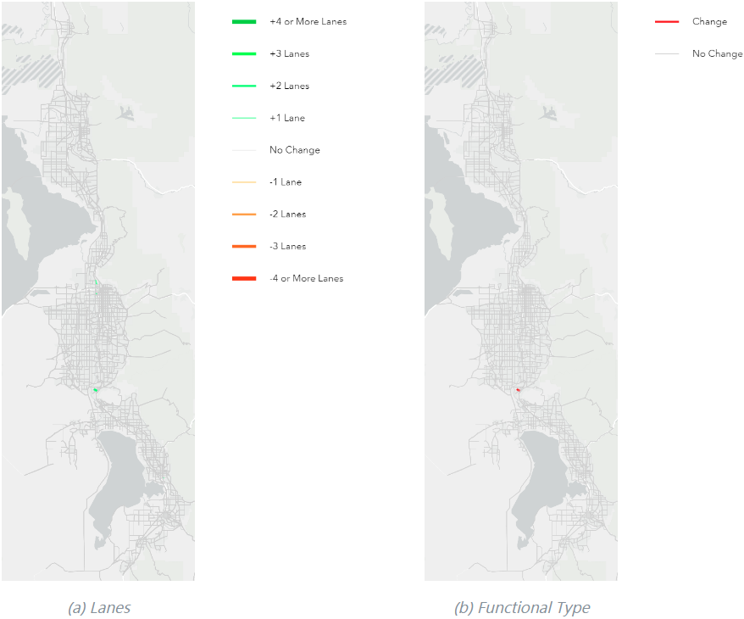

Figure 2.1 Lanes and Functional Type Model Differences – 2019

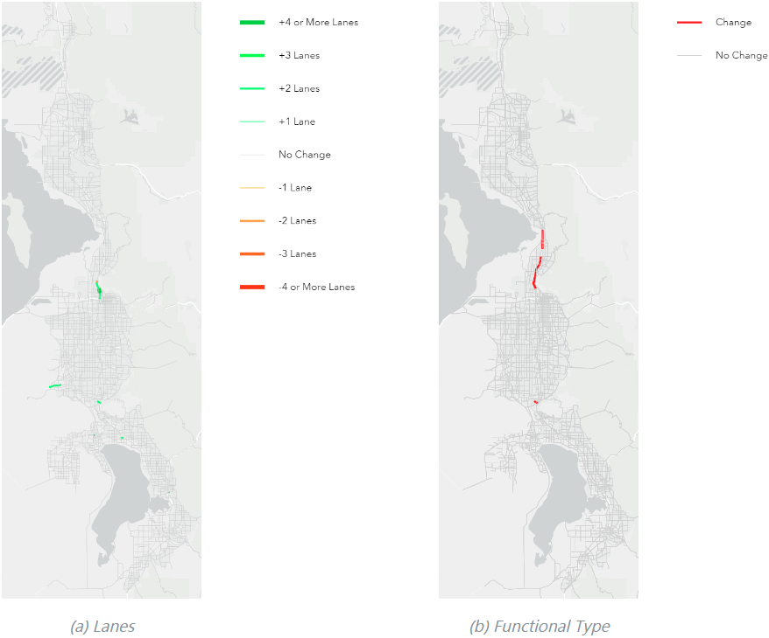

Figure 2.2 Lanes and Functional Type Model Differences – 2032

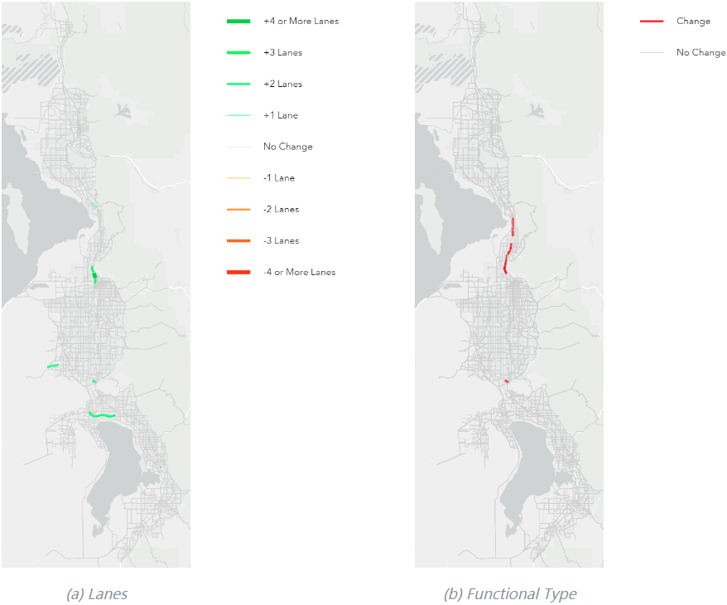

Figure 2.3 Lanes and Functional Type Model Differences – 2042

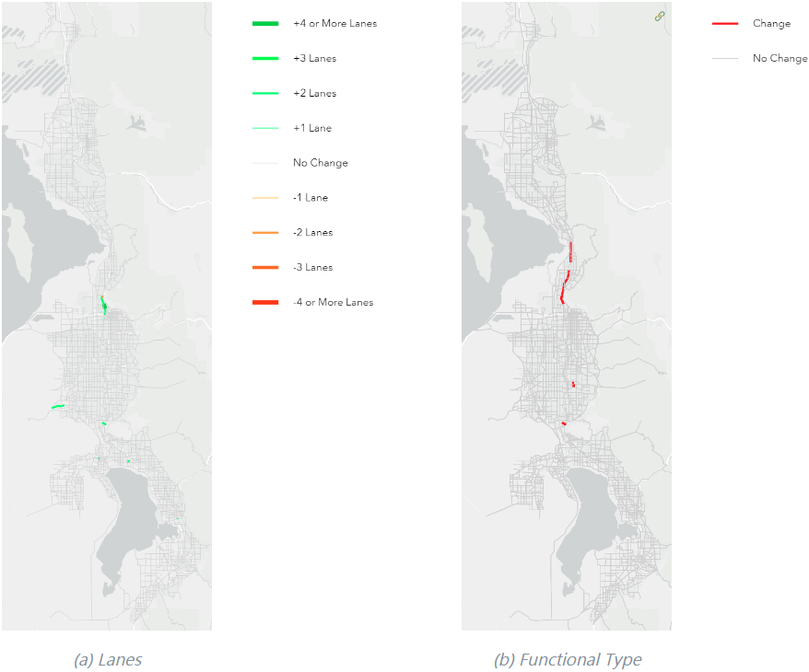

Figure 2.4 Lanes and Functional Type Model Differences – 2050

### Changes to the Highway Network Rail Component

Amendment #1 led to the following updates to the highway network’s rail component:

* A new Bluffdale commuter rail station was added at the former point of the mountain prison site (this included updating the rail speeds to/from this station)
* FrontRunner speeds were adjusted to match UTA’s FrontRunner Forward study. Phases and speed changes are outlined in Table 2.1.
* The following 6 transit speed fields corresponding to the 6 phases of the FrontRunner Speed Study were added to the highway network as a reference (information regarding the process for determining the transit speeds based on the FrontRunner Speed study can be found in the “*CRTSpeedSummaryFile.xlsx*” located in the *”Inputs/Transit”* folder):
  + **TRNSPD_FF1**
  + **TRNSPD_FF2**
  + **TRNSPD_FF3**
  + **TRNSPD_FF4**
  + **TRNSPD_FF5**
  + **TRNSPD_FF6**

Table 2.1 Version 9.0.2 Transit Speed Field Correspondence to UTA FrontRunner Study Reference Fields

|  |  |  |  |  |
| --- | --- | --- | --- | --- |
| Plan Phase (2023-2050) | | Assumptions | Field Calculation | Field Calculation (Additional) |
| Phase 1 | Fiscally Constrained | 15/30, POTM Station, Payson Extension | TSPD23_32 = TRNSPD_FF1 | Provo to Payson (TSPD23_32 = TRNSPD_FF2) |
| Needed | 15/30, POTM Station, Payson Extension | TSPD23_32U = TRNSPD_FF1 | Provo to Payson (TSPD23_32U = TRNSPD_FF2) |
| Phase 2 | Fiscally Constrained | 15/30, POTM Station, Payson Extension | TSPD23_42 = TRNSPD_FF1 | Provo to Payson (TSPD23_42 = TRNSPD_FF2) |
| Needed | 15/30, POTM Station, Payson Extension, Electrification | TSPD23_42U = TRNSPD_FF3 |  |
| Phase 3 | Fiscally Constrained | 15/30, POTM Station, Payson Extension, Electrification | TSPD23_50 = TRNSPD_FF3 |  |
| Needed | 15/30, POTM Station, Payson Extension, Electrification | TSPD23_50U = TRNSPD_FF3 |  |

*speeds received from UTA in March 2024

A comparison of the FrontRunner speeds and travel time savings between versions 9.0.2 and 9.0.1-patch2 are found in Table 2.2 through Table 2.5. The difference in speeds results in a savings of 10 to 15 minutes along the entire route in 2032 and 2042. In 2050, the difference in speeds results in a time savings of 26 to 33 minutes.

Table 2.2 FrontRunner Speed Differences – 2032 & 2042

|  |  |
| --- | --- |
| Northbound Travel Speed (mph) | Southbound Travel Speed (mph) |
|  |  |

Table 2.3 FrontRunner Speed Differences – 2050

|  |  |
| --- | --- |
| Northbound Travel Speed (mph) | Southbound Travel Speed (mph) |
|  |  |

Table 2.4 FrontRunner Travel Time Differences – 2032 & 2042

|  |  |
| --- | --- |
| Northbound Travel Time (minutes) | Southbound Travel Time (minutes) |
|  |  |

Table 2.5 FrontRunner Travel Time Differences – 2050

|  |  |
| --- | --- |
| Northbound Travel Time (minutes) | Southbound Travel Time (minutes) |
|  |  |

### Added Network QA-QC Folder

In the *“1_Inputs/3_Highway/_Network Processing Tools”* folder, the *“Network QA-QC”* folder was added containing new Jupyter Notebook files. The *“0-Network-QA-QC-Process.ipynb”* describes a process for verifying the quality of the highway network, segment shapefile, and transit networks before running/releasing a new version of the model. The *“1-Network-QA-QC-Checks.ipynb”* is a placeholder for the future checks that will be programmatically made. However, for now, this file is empty.

## Transit Networks

### Changes to Transit Line Files Due to Amendment #1

The following edits were made to the transit network to account for Amendment #1:

* Added a shuttle service at the Point of the Mountain in Phase 1 of the RTP
* Replaced BRT with LRT through the Point of the Mountain in Phase 2 of the RTP
* Added a new shuttle service at the Farmington Transit Station
* Added Bluffdale commuter rail station

With the Amendment #1 edits, transit projects crossing the border between Salt Lake and Utah counties are now consistent between WFRC and MAG’s unfunded need project lists.

Minor edits were made to the transit line files to ensure consistency with the changes made to the highway network.

# Compare Model Results

This section compares the model results between version 9.0.2 and version 9.0.1-patch2.

## Road Volume Comparisons

The comparison between daily volumes at the segment level can be found in Figure 3.1 for 2019 and 2050. Decreases in volume in version 9.0.2 compared to version 9.0.1-patch2 are shown in blue, while increases are shown in red. Figure 3.2 shows a similar comparison, displaying medium plus heavy truck volumes.

For 2019, the differences are negligible in all vehicle and truck volumes between the model versions.

For 2050, there are increases in both all vehicle and truck volumes on I-15 in Davis County due to increased general purpose capacity. Other differences are negligible.

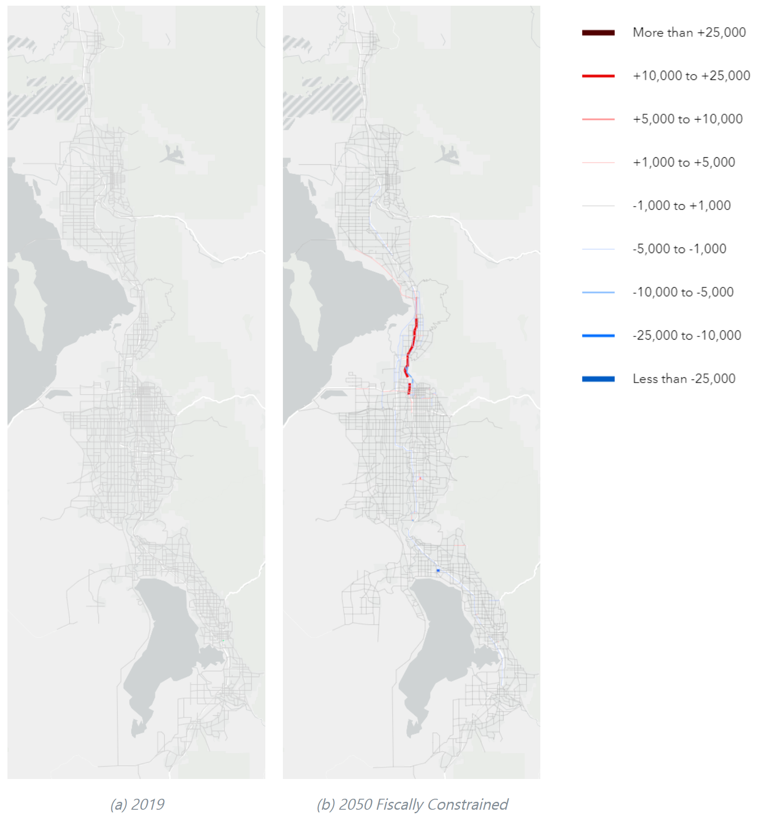

Figure 3.1 Daily Volume Comparison – All Vehicles

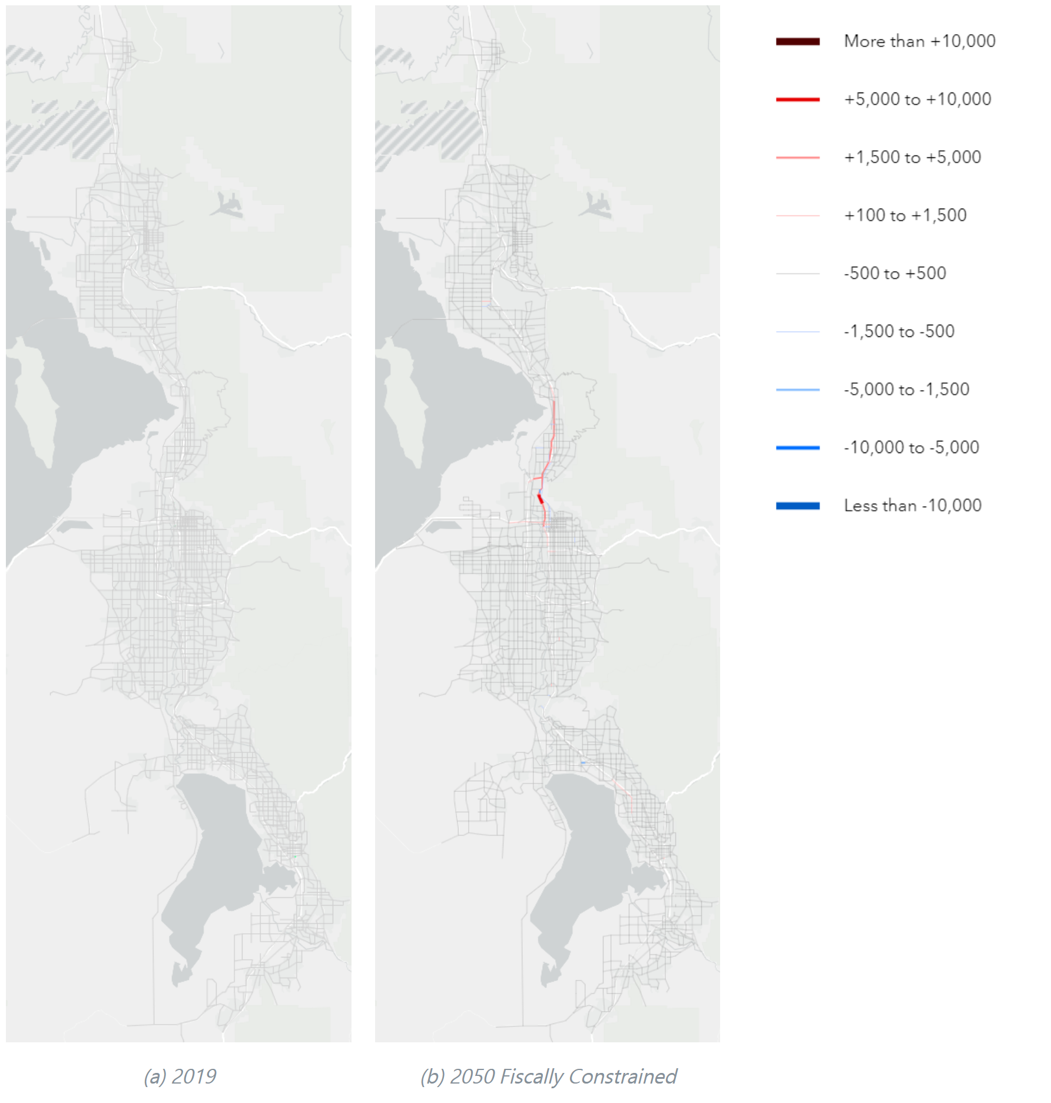

Figure 3.2 Daily Volume Comparison – Medium+Heavy Truck

## Transit Comparisons

Version 9.0.2 showed a slight increase in transit trips in 2042 and 2050 compared to version 9.0.1-patch2 (see Figure 3.3 through Figure 3.9). The total transit trips in 2050 for version 9.0.2 is 337,000 daily trips compared to the version 9.0.1-patch2 model that showed 320,000 daily trips, which equates to 5% more trips.

Commuter Rail saw the greatest increase in trips, some of which were new trips and some that had shifted from Express Bus to Commuter Rail. The shift from Express Bus to Commuter Rail is primarily due to the improvements in commuter rail speeds and to the additional stop in Bluffdale. These improvements make Commuter Rail more attractive and accessible which draws trips away from Express Bus since they compete for trips in similar markets.

BRT saw a slight increase in future trips. Light Rail, Core Route, and Local Bus trips remained relatively unchanged.

Figure 3.3 Daily Transit Trips - All Modes

Figure 3.4 Daily Transit Trips – Commuter Rail

Figure 3.5 Daily Transit Trips – Light Rail

Figure 3.6 Daily Transit Trips - Bus Rapid Transit

Figure 3.7 Daily Transit Trips - Express Bus

Figure 3.8 Daily Transit Trips - Core Bus

Figure 3.9 Daily Transit Trips - Local Bus